k
Builder Specifications
Builder Name: Richmond America
Salesperson: Corey Boser
Email: Corey.Boser@bldr.com
Sales Team: SalesTeamOne@buildersfirstsource.onmicrosoft.com
Confirm Plans with HCO
HCO Trumps Plan – Confirm with Corey if needed
Review all details on Plan
Stud Spacing
 | Standard: |  |  | 16” OC
 | Balloon Wall: |  |  | 16” OC
 | Detail - [W3-W6] |  |  | 12” OC
Junctions
 | Corners: |  |  | L-Type Junction
 | T Intersections: |  |  | L-Type Junctions
Typical Floor Heights
 | Main Floor Height: |  |  | See Elevation | 9-1-1/8
 |  |  |  | See Elevation | 10-1-1/8
 | Upper Floor Height: |  |  | See Elevation | 8-1-1/8
 |  |  |  | See Elevation | 9-1-1/8
 | Balloon wall height: |  |  | Depends of WH | 18-09-06 Typ.
 | Floor System: |  |  | 1-06-06
 | Stairs wall height: |  |  | 13-09-14 Typ.
Floor System
 | Decking: |  |  | ¾”
 | Floor system: |  |  | 18” Confirm on plan
Opening Assembly Specs
 | Headers |  |  | Up
 | Cripples |  |  | Yes, with stud layout.
 | Flush cripples |  |  | Yes.
 | Trimmers |  |  | Trimmers all the same height
Opening Specs
 |  |  |  |  | 6’ 8” |  | 8’
 | Swing Door
 |  |  |  | Height | 6’ 11” |  | 8’ 3”
 |  |  |  | Width | +2”
 | Double Door
 |  |  |  | Height | 6’ 11” |  | 8’ 3”
 |  |  |  | Width | 2 X Door + 2”
 | Bypass Door
 |  |  |  | Height | 6’ 11”
 |  |  |  | Width | Exact
 | Byfold door
 |  |  |  | Height | 6’ 11”
 |  |  |  | Width | Exact
 | Header Height |  |  | Main | 8’ 0 1/8”~
 |  |  |  | Upper | 7’ 0 1/8”~
Header Heights can vary by an ¼” with varying header material.

Bathroom
 | RO for Insert |  |  |  | Depth |  | Width
 |  |  |  | Tub/Shower | 32” |  | 5’ | Per Plan
 |  |  |  | Shower | 36” |  | 5’
Shear Callouts
 | 546 Detail – Extend header to end of Panel
 | 541 Detail – Sill Strap |  |  | (2) 2x windowsill, flat 2x6 blocking for 2 bays
 | Balloon blocking: |  |  | 8’ and 16’
 | Adjoining Panels Edges |  |  | Add double studs every 4’ for 5 and 6 SW (confirm with SW Schedule) Make sure to include double cripple studs under windows at appropriate location.
Half Wall Heights
 | Standard |  |  | Height | 42”
 | Kitchen |  |  | Height | 2-10-04
 | Under Stair |  |  | Height | 30” UNO |  | Look for cripple wall
 | VTP |  |  | None
Checklist
 | Garage Steps: 10” Drop on all Redwood Landing
 | When specified

Richmond America – General
- Review HCO for doors.
- Radon Pipes leave a note if makes an interference
- Detail 541 Called out applies (2) 2x on sill and filler and increasing ¼” on window height.
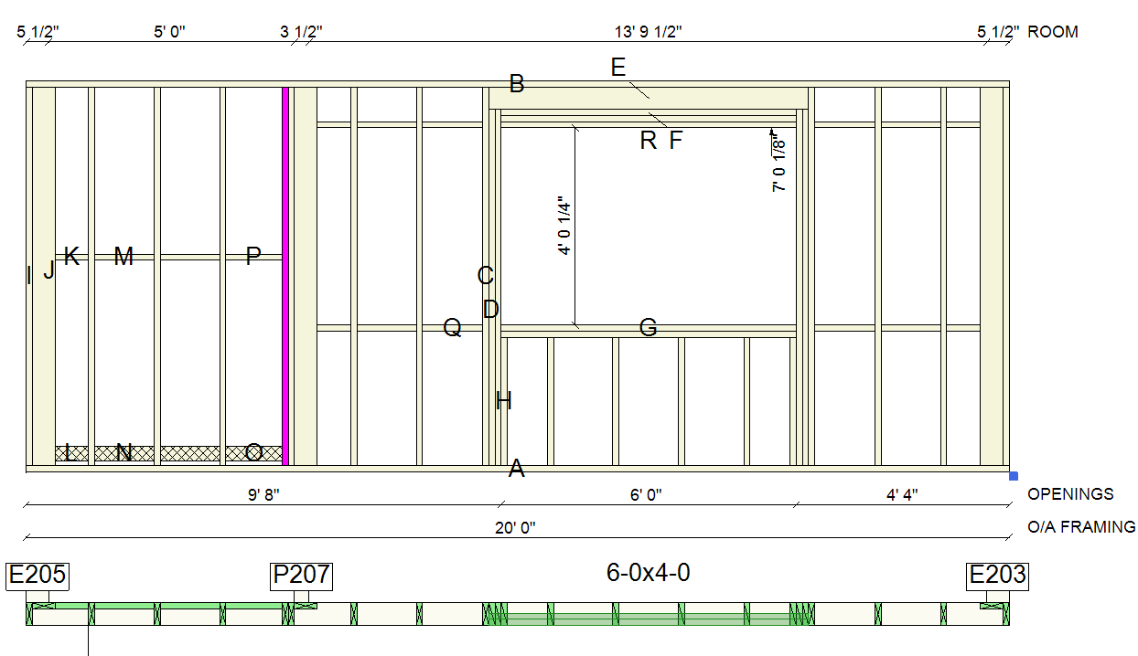

*** If calls out for a (2) CS strap the blocking will be double***
- Detail 541.0 only 1-ply sill and filler
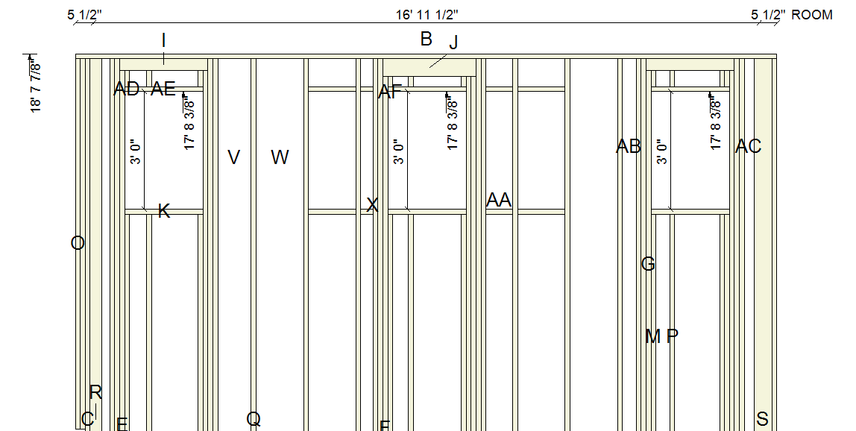

- Remember to include all blocking according to detail called out on shower/tub.
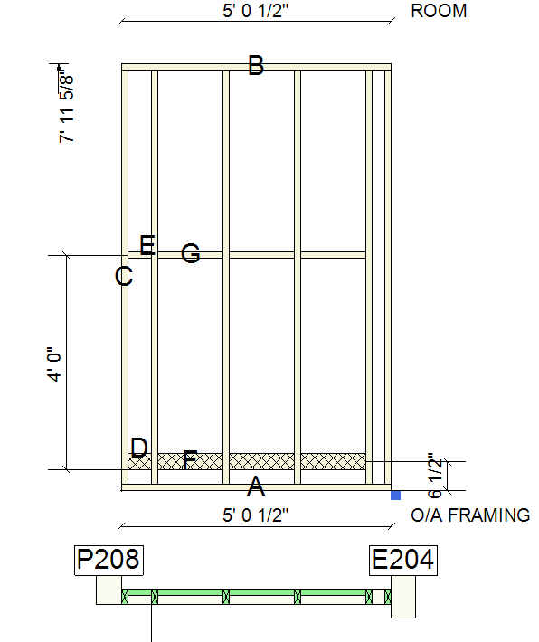
- Make sure to check wall heights, when plans have a powder room in the front of the building.
Richmond America – Maple Grove
- Increase 1/8” on window heights
Richmond America - North Haven
- Do not include garage door.
- Make sure the master closet door is 4” aways from the master bedroom to fit electrical switches.

Richmond America – Feedback record
8-30-2024
- Full Length (back and front wall).
- Balloon Stairs wall studs will go as “add from modeled only collection”.
- Careful with balloon frame walls to start and finish between interior walls, compare with floor truss layout.
- Look on HCO specification for open railing or half walls.
- Kitchen island wall 2-10-04.
- Fireplace opening cosmo or electric, Eli will create the opening.
- Blockings smaller than the standard measures (1-02-08 or 1-10-08) will go as No.2.
- Remember to look for cripple walls (under stairs) add a note on plan and elevation “Studs to be adjust on field”.
- (2) studs for balloon frame walls, make sure to apply if requires.
- Increase 1/8” on window heights only on Maple Grove subdivision.
- Garage walls go through end to end.
11-22-2024
- Look for 906 detail where 4x6’s are called out.

